## Library Module – Static Library

1. Create 3 files as below. Let cal_utility.c, .h files be part of the library
   * libapplication.c – will contain main() and will invoke functions in cal_utility.c
   * cal_utility.c – will contain atleast 2 or more functions [ You may add definitions of the functions in this file ]
   * cal_utility.h – will contain the extern declarations/prototypes of the functions in cal_utility.c

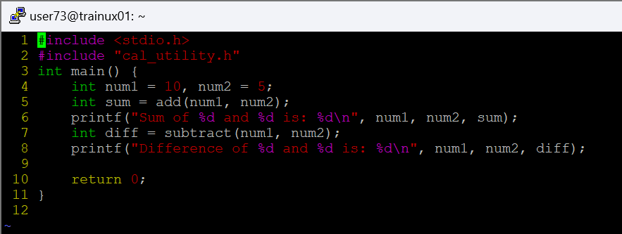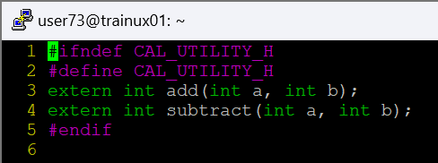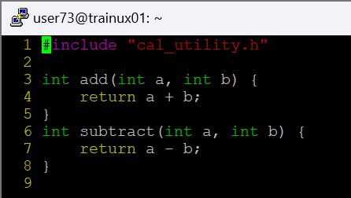

1. Refer the steps for static library based application and create a static library application using above set of files.

**Ans: gcc -c calutility.c**

**ar rcs libcalutility.a calutility.o**

**gcc -o application libapplication.c -L. -lcalutility**

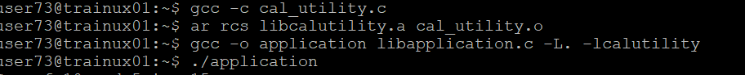

1. Execute the application created in step #2

